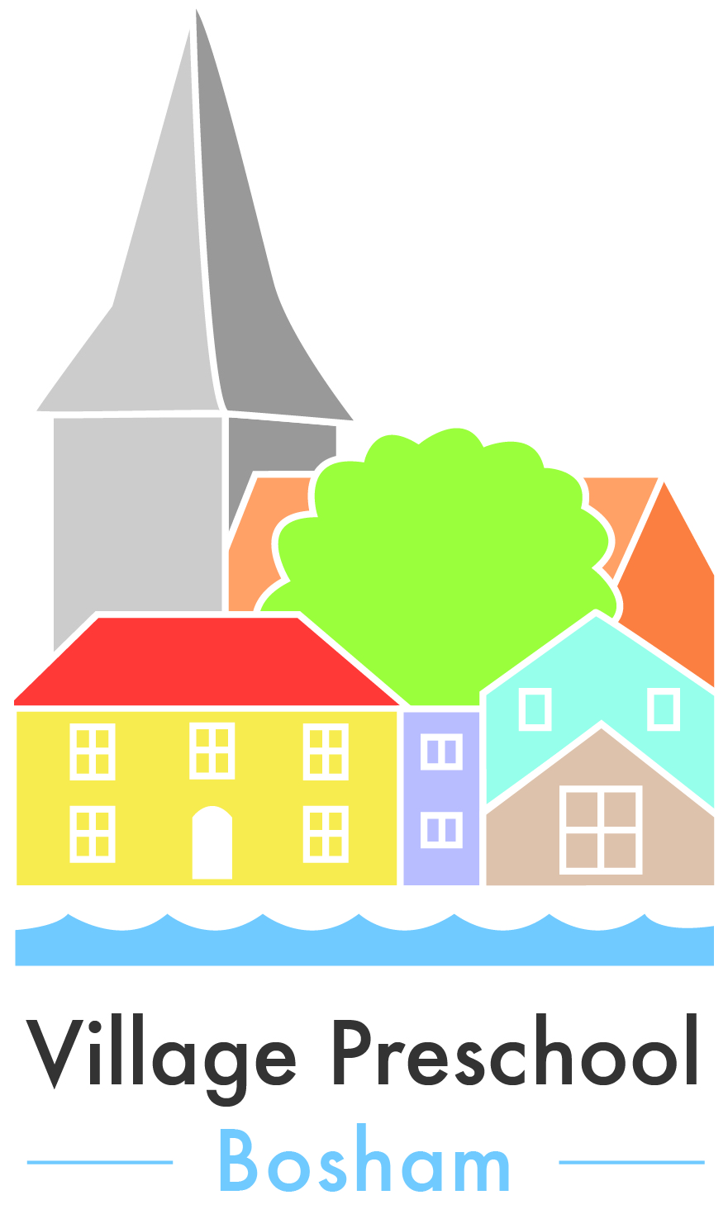
Operational Plan
Aims
To provide a nurturing and stimulating environment to suit the individual learning needs of all children.
Village Preschool Bosham is registered and inspected by OFSTED.
“A PLACE TO GROW”

Objectives
Children learn best when they are settled and happy and this is our primary aim when welcoming children to Village Preschool Bosham
Learning and development in preschool is facilitated through a wide variety of play based activities in line with the objectives of the Early Years Foundation Stage.
We aim to provide children with a well resourced setting where they have free access to inside and outside activities on a daily basis.

Inside
Environmental- Village Preschool Bosham is laid out in areas. These areas include:-
Small world
Construction (large and small)
Problem solving and numeracy
Creative and messy play area (for activities such as painting, cutting and sticking, play dough and malleable and sensory experiences)
Mark making area
Sand and water
Role play
Reading and quiet area

We participate in regular music sessions and dancing activities in the large school hall.

Outside
Our fantastic and stimulating outdoor facility is an extension of our early years setting, and used as an outdoor classroom. Children have access to the outdoor area throughout the session. We promote every area of development through outdoor play using both structured and child initiated activities.
We have our secure area for the children to use. It is very well equipped with a large climbing frame.
A gazebo provides shelter and shade so we can be outside whatever the weather.

We have an outside sandpit, water tray, sensory materials, construction and musical instruments for the children to explore.

Personal, Social and Emotional Development
At Village Preschool Bosham we use a Key Person system. Each child is allocated a key worker during the settling in period. The Key Person has a responsibility for observing child development and completing their children’s development records. Village Preschool Bosham has a comforting family atmosphere, where all staff will have input into the children’s records and hopefully parents and other carers will add to these records. All staff are respectful of any information given and it remains confidential to the preschool.

We cannot emphasise enough that our whole teaching and learning ethos is focused on the needs of individuals. Activities are planned based on staff observations of the children and their learning needs.

We pride ourselves on our caring and skilled preschool staff who are friendly and approachable. As parents ourselves, we have a personal knowledge to complement our professional experience of young children.

Policies and Procedures
These are held in preschool, and shared with every parent or carer new to our setting. There is a full copy available to parents on the website as well as in a folder inside the hall.

Grouping of Children
As we take children from 2-5 years at Village Preschool Bosham, we are very aware of the differing stages of development, and adapt our activities to make them accessible to all children.
A typical session will include:
Staff Registration sign in
Informal name/ picture registration by children
Free play guided by adults (continuous provision both inside and out and focused activities)
Snacktime (a healthy snack and a drink of milk or water)
Musical opportunities (instruments, songs and rhymes and dancing)
Going home preparation (regular song)
Staff sign out

Health and Safety Procedures
Village Preschool Bosham has internet access and a mobile phone available at all times.Nichola webb and Maria Newton are trained and qualified in paediatric first aid.
The child protection officer is Nichola webb. All staff have attended child protection training.
Daily risk assessments are undertaken daily to maintain safety inside the preschool and in the outdoor area.
Fire Drills are held half termly and records are maintained within preschool.

Activities
Activities are a balance of child selected and adult led, in line with the guidance from The Early Years Foundation Stage curriculum (2014).

Village preschool Bosham operates on a continuous provision basis, which means that the children can chose their activities freely from the resources in the setting.

An important part of our routine includes learning how to care for toys and putting things away correctly.
Adult led activities are planned each week based on observation of individual learning needs. These operate very flexibly to allow for any unexpected and exciting events; such as snowfall or a new baby!
Further information for parents is always available from the weekly planning sheets through the Key Person or their child’s learning journal, where individual next steps are demonstrated

Staffing Structure
Nichola Webb - Pre-School Manager
Maria Newton– Deputy Manager
- Pre-School Practitioner
- Pre-School Practitioner

.

